Intro to Scripting Semester Long Project Writeup

Game-Time Limiter

Eric Ragle

CISP 1020 K70

#### Table of Contents

**How it will achieve its goals** 3

Consistent Coding Style 3

Using Bash 3

Using Batch 3

Using Python 3

Using a Windows Environment 3

Using a Linux Environment 3

Manipulating Operating System Environments 3

API Consumption 4

API Creation 4

Script Reliability 4

Script Robustness 4

Socket Communication 4

Proper Error Handling 4

Logging 4

Text/Binary File Manipulation 4

Integrating Multiple Languages into Workflows 4

Integrating Multiple Environments into Workflows 5

Resilient, Robust, Distributed Script Design 5

**Expected Outcome** 5

**State Machine Diagram** 5

**Deployment Diagram** 6

**API List** 6

### How it will achieve its goals

##### Consistent Coding Style

The best way to achieve a consistent coding style in your work is to use a style guide. I will be frequently referring to official guidelines for Batch, Bash, and Python.

##### Using Bash

I will create a Bash script that manages time tracking and enforces restrictions.

##### Using Batch

I will create a Batch script that notifies the user when their allowed time is almost out.

##### Using Python

I will create a Python script that manages the communication between the Linux server and Windows clients.

##### Using a Windows Environment

The Batch script will be executed in a Windows environment.

##### Using a Linux Environment

The Bash and Python scripts will run in a Linux environment.

##### Manipulating Operating System Environments

The Linux server will use system tools like cron, ps, and kill to track activity.

The Batch script will modify environment variables and use taskkill to close the game after the time limit.

##### API Consumption

The server will use Flask in Python and the Windows client can interact with it to check their time and get notifications.

##### API Creation

I am not yet sure how I will go about incorporating the creation of an API into my project.

##### Script Reliability

I will make sure my scripts’ executions are verifiable and are able to handle edge cases by creating a mechanism.

##### Script Robustness

I will make sure my scripts can handle edge cases by implementing proper error logging and handling.

##### Socket Communication

I plan to use Python’s socket library for my client-server communication features.

##### Proper Error Handling

Each script will have the implementation of error handling features. The Python script will gracefully handle network issues and failed requests. The Batch script will handle unexpected terminations.

##### Logging

I will use logging libraries in Python to log server activity. The Batch script will be able to log the user’s activity.

##### Text/Binary File Manipulation

The Batch server can modify logs to record the times when users receive time warnings and when their time is up.

##### Integrating Multiple Languages into Workflows

The Python script will be used to allow the Bash and Batch scripts to communicate.

##### Integrating Multiple Environments into Workflows

Python sockets will be used to allow the Windows and Linux environments to communicate.

##### Resilient, Robust, Distributed Script Design

The server will handle potential crashes, sockets will make sure the server and client always communicate, and Batch and Bash will handle communication failures and retry tasks when appropriate.

### Expected Outcome

The expected outcome is a basic set of scripts that allows for a user to restrict the time they spend in an application.

### State Machine Diagram

Here is a state machine UML diagram of the basic functionalities of my set of scripts

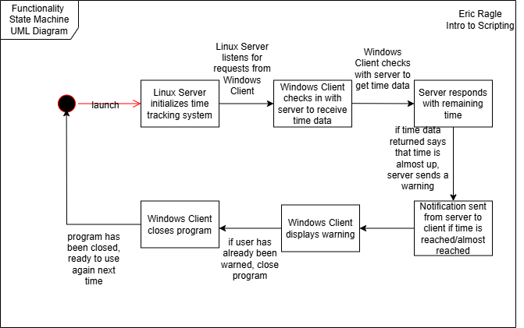

### Deployment Diagram

Here is a deployment UML diagram of the physical deployment of my scripts.

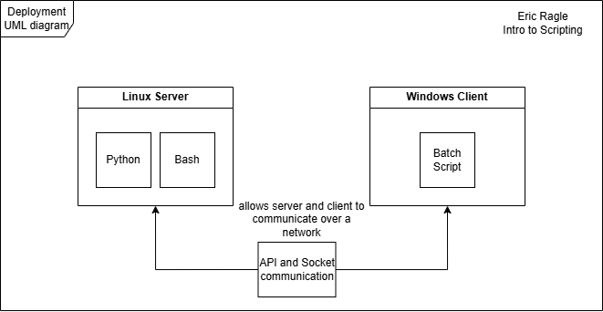

### API List

As of now, the APIs I plan to integrate are Python Flask, Python logging libraries, Python socket libraries, and psutil to track server activity.